**PERSONAL EXPENSE TRACKER APPLICATION**

PROPOSED SOLUTION

NOVELTY:

In this application, more than one user can login to the same device. And one account can also be used on many devices at a time. Updating some expenses manually may be mistakenly forgotten so, there is a feature to set a reminder by the user at a particular time. On a daily basis at that particular time it shows a reminder to enter the present day’s expenses. So that user can feel free from forgetting. A text area has been provided for the user to enter the expense details along with the amount that has been entered manually. A user can also save the money from the total amount so that it will be kept separately and maintained until the user unlocks.

FEASIBILITY:

The FLASK framework will be used in the development of this application. Compared to the Django web framework, Flask is thought to be more Pythonic because the comparable web application is usually more explicit. Flask is also simple to use for beginners. Flask includes a large selection of code libraries and extensions that transform the web framework from a microframework into a fully functional tool for building online applications. The Werkzeg WSGI toolkit and the Jinja2 template engine serve as the foundation for Flask.

BUSINESS MODEL:

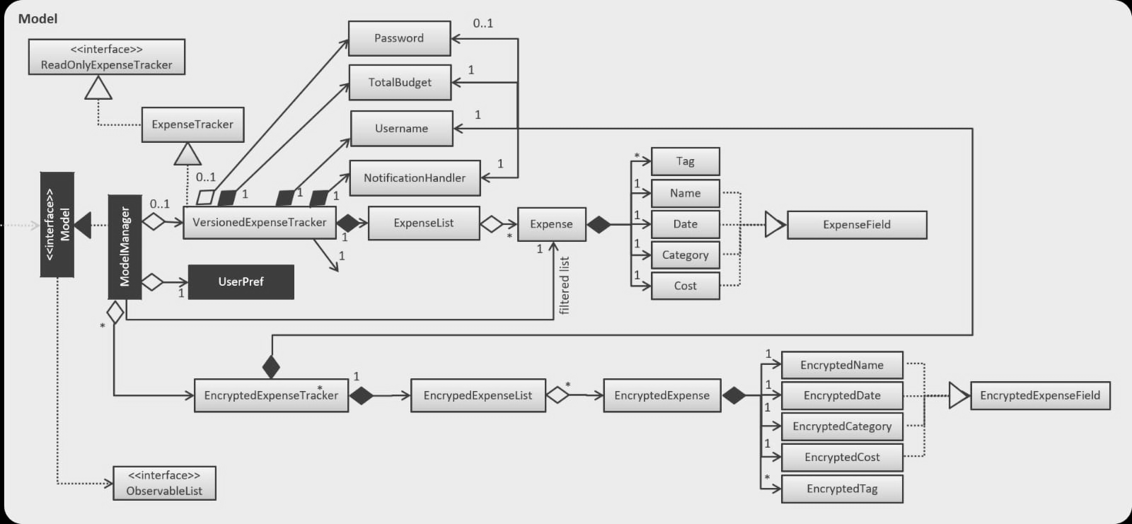

SOCIAL IMPACT:

Since it is a personal expense tracker there won’t be any social impact existing.

SCALABILITY:

When it comes to expense tracker it takes a lot of data from the user and it is necessary too. This application will delete the data after a certain period of time only if the user permits. So, this could help the application to work in a better way for a long time. The input data will be in the form of a .csv file so it makes the process easier and it is a lightweight file. So, everytime the application will feel like a lightweight application with all necessary data.